|  |  |
| --- | --- |
|  |  |
|  | |

**How you can keep young people safer online over the Christmas period**

**... and beyond!**

No doubt you’ll have a family member who has asked for some form of technology that links to the internet for Christmas, be it a new smartphone, tablet or games console. While their device will provide them with hours of entertainment, it can also present new risks. Here are 4 steps you can take to make sure that young people are safer online over the Christmas period and beyond.

**1. Set up parental controls**

Parental controls can be a great tool to help protect young people online and should be installed on any new device that they use. Parents and carers frequently want the information they need to use these controls effectively and this [Thinkuknow article](https://www.thinkuknow.co.uk/parents/articles/Parental-controls/) should demystify the actions you need to take.

There is plenty of further advice and support on how to keep their child safe online on parent websites.=

**2. Start a conversation about communicating safely online**

A new device enables your young person to gain access to new communities through online gaming and social media. If you can, make time before the end of term to start a conversation with young people about how they use online technology and what it means to them. You can use this as a way to remind them of some key strategies for safer internet use, for example:

* Be careful with what they share, including images, videos and personal information.
* Take control of who sees what they post by using privacy settings.
* Be mindful of who they are chatting to and gaming with – do they really know and trust them? If not, don’t share personal details or agree to meet them in other online spaces.

**3. Remind young people how to report anything worrying**

It’s important that young people know where to go if they come across something online that worries them or makes them feel uncomfortable – especially as contact with trusted sources of support may not be available over the holidays.

You could:

* Help them to identify trusted adults that they can approach during the holiday period, and encourage them to speak to the adult immediately if they have any concerns.
* Familiarise and talk them through how they can make a report to CEOP if something has happened to them online or they’re worried about what a friend is doing online.
* Remind them that they can contact Childline if they have any other worries, for example if they are being bullied.
* Share this with the parents or carers of friends or relations over the holiday period.

**4. Plan opportunities to reinforce messages for the new year**

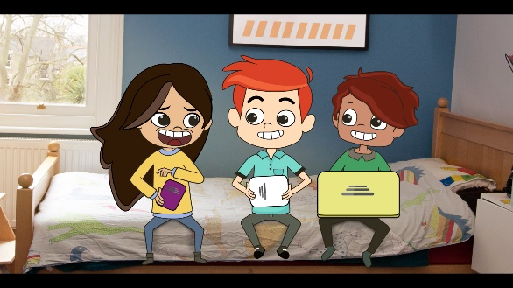Build on your conversations and develop their online resilience by using [Thinkuknow resources](https://www.thinkuknow.co.uk/parents/Listing/?cat=75&ref=4824#mMain) to access online safety resources during the holiday period.

Tips for helping your child to regulate their own use and take the more positive approach to the internet that seems to lead to greater safety:

* Rather than making inflexible rules, have a conversation. It can be tempting to lay down hard and fast rules - to order your kids not to visit certain websites or to switch all screens by dinner time. But even a child who has no access to a computer at home may be able to surf the web on their phone, a friend’s tablet or laptop or even at school, and research shows that children who have very restrictive parents are generally less resilient than their peers.
* Calmly and rationally discussing the risks of some online activities can help your children decide for themselves that uploading that picture or clicking on that link isn’t worth the risk.
* Create a supportive environment for exploration and learning. Parental support can make a big difference in offline success, but it’s now seeming just as crucial to online resilience. Make it clear you support your child seeking out new opportunities. Encourage them to research topics that interest them, use the internet for homework and connect positively with friends and family via social media.
* Don’t be too hands-off. Research shows that parental interest and involvement is positively correlated with online resilience, so don’t stay completely removed from your child’s online life. Ask them to show you their favourite websites, videos and apps, and talk to them about how they interact online. Take a real interest in what they're doing. It is children who feel unconditionally supported (but who have clear boundaries) who feel most secure and tend to be safer

Throughout, remember that your focus shouldn’t be to put young people off using their new device or encourage you not to buy it in the first place. Scaremongering is not effective and makes young people far less likely to ask you for help if they encounter a threat online. Aim to provide a balanced view that encourages them to share their thoughts and engage with new ideas about staying safe.

School Safeguarding Lead: Mrs Paula Shaw

Contact Details: [Office@greathorwoodschool.org](mailto:Office@greathorwoodschool.org) Telephone 0126 712622